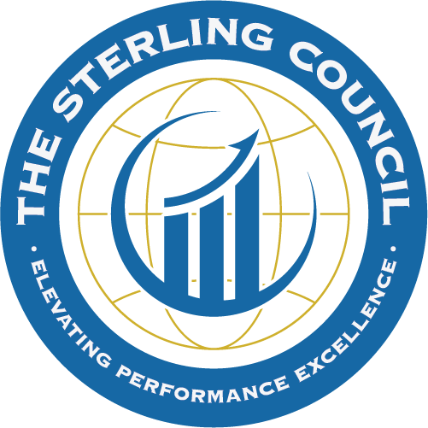

The Sterling Council

2025-26 Cycle – Sterling Assessment

Organizational Profile Questions

Name of the Organization:

Created by: Revision Date:

The Organizational Profile sets the context for understanding your organization, and how it operates. It is an invaluable tool for new, and seasoned employees to fully understand your organization.

Below are the questions for the Organizational Profile, which can also be found in the Sterling Management Resource Guide. For your upcoming Sterling Assessment, please provide responses to the Organizational Profile questions. Your responses establish a snapshot of your organization, including your operating structure and key elements of organizational success following each specific question. Responses may be provided in paragraph or bulleted format, and may also include graphics, models, or tables, as appropriate.

P.1 ORGANIZATIONAL DESCRIPTION: What are your key organizational characteristics?
a. Organizational Environment
(1) Product and/or Service Offerings:
What are your main products and/or services?

What is the relative importance of each product or service to your success?

What are the delivery methods for these products and/or services?

(2) Mission, Vision, Values, and Culture:
What is your Mission?

… your Vision?

… and your Values?

What are the defining characteristics of your organizational Culture?

What are your organization’s Core Competencies, and what is their relationship to your Mission and Vision?

(3) Workforce Profile:
What is your workforce profile?

What are your workforce or employee groups and segments, and the key engagement drivers for each?

What key changes are you experiencing in your workforce capability, capacity, and composition?

(4) Assets:
What are your major assets, such as facilities, equipment, technologies, and intellectual property?

(5) Regulatory Environment:
What are your key applicable regulations; and accreditation, certification, or registration requirements?

b. Organizational Relationships

- Organizational Structure:
What are your organizational leadership and governance structures?

What are the key components of your organization’s leadership system?

What are the reporting relationships among your governance system, senior leaders, and parent organization, as appropriate?

- Customers and Stakeholders:
What are your key market segments, customer groups, and stakeholder groups, as appropriate?

What are their key requirements and expectations for your products and/or services, customer support services, and operations, including any differences among the groups?

(3) Suppliers, Partners, and Collaborators:
What are your key types of Suppliers,

Partners,

and Collaborators?

What role do they play in producing and delivering your key products and/or services, and customer support services?

What role do they play in contributing and implementing Innovations in your organization?

What are your key Supply-Network requirements?

P.2 ORGANIZATIONAL SITUATION: What is your organization’s strategic situation?
a. Competitive Environment
(1) Competitive Position:
What are your size, share, and growth in your industry or the markets you serve?

How many, and what types, of competitors do you have?

What differentiates you from them?

- Competitiveness Changes:
What key changes, if any, are affecting your competitive situation, including changes that create
opportunities for collaboration and innovation, as appropriate?

(3) Comparative Data:
What key sources of comparative and competitive data are available from within your industry?

What key sources of comparative data are available from outside your industry?

What limitations, if any, affect your ability to obtain or use these data?

b. Strategic Context:
What are your key strategic Challenges (internal),

Threats (external),

Advantages (internal),

and Opportunities (external)?

c. Performance Improvement System:
What is your overall system for performance improvements?

What key tools and methods are used as part of this system?

NOTES

